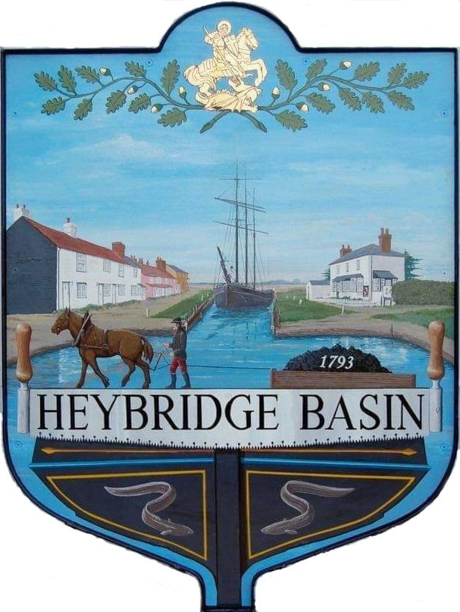

HEYBRIDGE BASIN PARISH COUNCIL

Minutes of the Full Council meeting of Heybridge Basin Parish Council held on Tuesday 16th January 2024 at 6.30pm, at The Lock Tea Room.

PRESENT

In the Chair: M. Hodges Absent: 0
Councillors: J. Sjollema District Councillors: N. Spenceley
C. Swann N. Swindle
R. Bryson
M. Hobden Public: 5
G. Howat
C. Edmond Officers: G. Lake – Clerk

It was noted that this meeting was being recorded by the Clerk.

23/148 Chair’s Welcome
Cllr Hodges opened and welcomed everyone to the meeting. Cllr Hodges said a few words on the sad passing of former Cllr Keith Lawson: ‘He was a very active member in the referendum group that lead to the establishment of this Parish Council, he was a foundation councillor and the first elected Chairman’.
As a mark of respect, a one minutes silence was held.

23/149 Apologies for Absence.
There were none.

23/150 To receive Declarations of Interest in accordance with the Council’s Code of Conduct and with section 106 of the Local Government Finance Act 1992.
Cllr Hobden – Non-Pecuniary – HBSA, Basin Oars and HB Rivercare; Cllr Howat – Non-Pecuniary – HBCSA, C. Edmond – Non-Pecuniary – Essex Waterways and Director of Cloughton Court Management Company Ltd and Cllr Swann – Non-Pecuniary – DMCP and owner of the tearoom.

23/151 Keith Lawson Commemoration
  - To consider a permanent tribute to Keith Lawson’s contribution to the village and agree any action to be taken.
It was resolved that the Council would consider appropriate ideas and bring to a meeting later in the year.

23/152 To sign as a correct record the minutes of the extraordinary meeting held on 12th December 2023.
The Minutes as previously circulated were agreed as a correct record.

23/153 To receive a report from the District and County Councillors for the area on any matters of interest.
A report was received from the District Councillors. There were no reports from County Councillors.

23/156 Finance.
- To approve
- Payment requests for December 2023/January 2024.
The Payments as previously circulated were approved.
- Receipts for December 2023/January 2024.
The receipts as previously circulated were approved.
- Accounts for the nine months to 31st December 2023.
An anomaly was found in the accounts and this item has been deferred to next month.
- To consider amending the Unity Bank permission levels for councillors and agree any action to be taken.
It was resolved to amend the banking permissions for all authorised users to be able to view the accounts.

23/157 Interim Internal Audit
  - To note and approve the Interim Internal Audit Report from April Skies for 2023/24.
The Interim Internal Audit was noted and approved with recommendations to be actioned accordingly.

23/158 Public Forum
No members of public wished to speak.

23/159 Planning Applications
- To consider any planning applications received after the publication of the agenda and to agree the action to be taken.

23/01239/FUL – Land at Tideways - 9 Basin Road – New attached dwelling on land adjacent to No.9 Basin Road. Culverting of existing ditch full width of site. Widening of existing access.
It was resolved to recommend the refusal of planning permission with the same comments as The Conservation Society.

23/01211/HOUSE – Adelante - Harfred Avenue – First floor front/side extension. Alterations to fenestration including cladding and new ground floor bay window. Addition of porch canopy and erection of car port.
It was resolved to recommend the granting of planning permission as it is a modest first floor/front side extension to an existing building and has been designed in a very sympathetic way to the architecture to the existing buildings.

24/00026/TCA – Land Adjacent Myrtle Cottage - Horse Chestnut Tree – Fell
Cllr Edmond left the meeting.

It was resolved to recommend the granting of planning permission as the Council support the reasons given from the insurance company, with the condition that appropriate trees are planted in its place.

Cllr Edmond returned to the meeting.

23/160 Daisy Meadow Car Park (DMCP)
- To receive an update from the Working Group and agree any action to be taken.
It was resolved for the Clerk to liaise with the owners of Rohan House and Petro Designs to pencil in the condition survey as close as possible to the estimated road works commencement date.

Haydn Evans undertook their surveys on Monday 8th January 2024. The Eco surveyors advised that the Laurels and Conifers would need felling prior to March due to the nesting season. The Condition to remove these is to have written permission of what the plan to replace – Eco surveyor advised that this doesn’t need to be in the same position as we are widening road. It was resolved for Clerk to contact MDC explaining the needs of the work to be completed in the coming weeks, and that a planting plan would be submitted prior to planting taking place.

- To consider the quotes received to fell the Laurels and Conifers and agree any action to be taken.
Cllr Swann left the meeting.

It was resolved to accept the quote from Blackwater Tree Specialists. Cllr Bryson abstained from the vote.
Cllr Swann returned to the meeting.

- To consider the quotes received to remove the tree stumps and agree any action to be taken.
No quotes had yet been received.

23/161 Hedges along Basin Road
  - To receive an update from Councillor Bryson and agree any action to be taken.
It was resolved for the Clerk to write to the owners of the hedges along Basin Road.

23/162 Bird Boxes
- To consider a proposal for a bird nest project from Councillors Hodges and Swann and agree any action to be taken.
It was resolved to support the bird nest project. Cllrs Hodges and Swann had built some bird boxes and placed them in the trees in DMCP. Council resolved that they were happy to keep them.

23/163 Newsletter
- To consider items to be included in the next Parish Council Newsletter and delegate articles to Councillors.
- Bird Boxes – Cllr Hodges
- Precept – Clerk
- D-Day 80 – Cllr Hodges
- VDS – Cllr Howat
- DMCP – Cllr Bryson
- K. Lawson Tribute – Cllrs Edmond and Sjollema

23/164 Correspondence
- To note correspondence received and any actions to be taken.
Members of the public and District Councillors left.

Correspondence was noted and responses were agreed.

23/165 Pursuant to section 1(2) of the Public Bodies (Admission to Meetings) Act 1960 it is resolved that, in view of the confidential nature of the business about to be transacted, it is advisable in the public interest that the press and the public be excluded, and they are instructed to withdraw.

23/166 URC
  - To receive an update from the Councillor Hodges and agree any action to be taken.
An update from Cllr Hodges was received. It was resolved for Cllr Hodges to draft a letter inviting the owners to a meeting and for the Clerk to send.
  - To discuss appealing the Community of Asset Value decision and agree any action to be taken.
It was resolved for the Clerk to send the drafted appeal to MDC.

23/167 Personnel Matters
- To receive a report from the Chair of the Personnel Committee.
A report was received from Cllr Bryson and noted.

There being no further business the meeting closed at 08:09pm
Provisional Date of the next Council Meeting Tuesday 13th February 2024

Clerk Contact details: clerk@heybridgebasinpc.org.uk
Website: www.heybridgebasin-pc.gov.uk

